Write a detailed comparison between arrays and linked lists based on the following:
1. Memory Layout
Arrays store elements in contiguous (continuous) memory locations, meaning each element is placed next to the previous one. This allows easy calculation of any element’s address using its index.
Linked lists store elements in non-contiguous memory locations. Each element is stored in a node that contains the data and a pointer/reference to the next node in the list.
2. Access Time
Arrays allow direct (random) access to elements using an index, so accessing any element takes O(1) time.
Linked lists allow only sequential access, meaning you must traverse from the first node to reach a specific node. Accessing an element therefore takes O(n) time.
3. Insertion and Deletion
In arrays, insertion or deletion of an element usually requires shifting other elements, which makes the operation O(n) in most cases.
In linked lists, insertion and deletion are easier because only pointer references need to be updated. If the position is known, the operation can be done in O(1) time.
4. Cache Friendliness
Arrays are cache-friendly because elements are stored in continuous memory, allowing the CPU cache to load nearby elements efficiently.
Linked lists are not cache-friendly because nodes are scattered in different memory locations, which reduces cache efficiency.
5. Memory Overhead
Arrays require memory only for storing the elements, so they have low memory overhead.
Linked lists require additional memory for pointers or references in each node, which increases memory usage.
6. Searching
In arrays, searching can be done using linear search (O(n)) or binary search (O(log n)) if the array is sorted.
In linked lists, searching is usually done using linear traversal, which takes O(n) time because elements cannot be accessed directly.
7. Real-World Use Cases
Arrays are commonly used in situations where fast access and fixed-size data storage are needed, such as image processing, lookup tables, and mathematical computations.
Linked lists are used when frequent insertion and deletion are required, such as in implementing stacks, queues, playlists, and dynamic memory management.
Why is random access efficient in arrays but not in linked lists?
Random access is efficient in arrays because elements are stored in continuous memory, so the address of any element can be calculated directly using its index. This allows immediate access in constant time (O(1)).
In linked lists, elements are not stored in continuous memory and each node only contains the address of the next node. Therefore, to access a specific element, the list must be traversed from the beginning, making it slower and taking O(n) time.

Q2. Implement Basic Array Operations

1. Problem Statement
Write a C program to perform basic operations on an array:
Traverse the array
Insert element at beginning
Insert element at end
Insert element at any position
Delete element from beginning
Delete element from end
Delete element from any position
Search an element
The program should demonstrate concepts of array indexing, overflow handling, and shifting cost.

2. Algorithm / Logic

Traverse
Check if array size is 0.
If empty → print message.
Otherwise print elements from index 0 to size-1.

Insert at Beginning
Check if array is full.
Shift elements right.
Insert new element at index 0.
Increase size.

Insert at End
Check if array is full.
Insert element at size.
Increase size.

Insert at Any Position
Validate position.
Shift elements right starting from last element.
Insert element.
Increase size.

Delete at Beginning
Check if array empty.
Shift elements left.
Decrease size.

Delete at End
Check if array empty.
Decrease size.

Delete at Any Position
Validate position.
Shift elements left.
Decrease size.

Search Element
Traverse array.
Compare each element with key.
If match found → print position.
Otherwise print not found.
Soucre Code:
#include <stdio.h>
#include <stdlib.h>
int Arr[20] = {1, 2, 3, 4, 5, 6};
int ArraySize = 6;
void Traverse()
{
if (ArraySize == 0)
{
printf("No element in array");
}
else
{
for (int i = 0; i < ArraySize; i++)
{
printf("%d", Arr[i]);
}
}
}
void InsertAtEnd(int value)
{
if (ArraySize == 0)
{
Arr[0] = value;
ArraySize++;
}
else
{
Arr[ArraySize] = value;
ArraySize++;
}
}
void InsertAtFirst(int value)
{
if (ArraySize == 0)
{
Arr[0] = value;
ArraySize++;
}
else
{
for (int i = ArraySize; i > 0; i--)
{
Arr[i] = Arr[i - 1];
}
Arr[0] = value;
ArraySize++;
}
}
void InsertAtAnyPosition(int value, int position)
{
if (ArraySize == 0)
{
Arr[0] = value;
ArraySize++;
}
else
{
for (int i = ArraySize; i >= position; i--)
{
Arr[i] = Arr[i - 1];
}
Arr[position - 1] = value;
ArraySize++;
}
}
void DeleteAtEnd()
{
if (ArraySize == 0)
{
printf("No element in array");
}
else
{
ArraySize--;
}
}
void DeleteAtFirst()
{
if (ArraySize == 0)
{
printf("No element in array");
}
else
{
for (int i = 0; i < ArraySize - 1; i++)
{
Arr[i] = Arr[i + 1];
}
ArraySize--;
}
}
void DeleteAtAnyPosition(int position)
{
if (ArraySize == 0)
{
printf("No element in array");
}
else
{
for (int i = position; i < ArraySize - 1; i++)
{
Arr[i] = Arr[i + 1];
}
ArraySize--;
}
}
void Search(int value)
{

if (ArraySize == 0)
{
printf("No element in array");
}

else
{
for (int i = 0; i < ArraySize; i++)
{
if (Arr[i]==value)
{
printf("Value found\n");
return;
}
}
printf("Value not found\n");
}
}
int main()
{
printf("Initial Array:");
Traverse();
printf("\n--- Inserting 7 at End ---");
InsertAtEnd(7);
Traverse();
printf("\n--- Inserting 0 at First ---");
InsertAtFirst(0);
Traverse();
printf("\n--- Inserting 99 at Position 3 ---");
InsertAtAnyPosition(99, 3);
Traverse();
printf("\n--- Searching for 99 ---");
Search(99);

printf("\n--- Searching for 500 ---");
Search(500);

printf("\n--- Deleting at First ---");
DeleteAtFirst();
Traverse();

printf("\n--- Deleting at End ---");
DeleteAtEnd();
Traverse();

printf("\n--- Deleting at Index 2 ---");
DeleteAtAnyPosition(2);
Traverse();
return 0;
}

4. Dry Run
Initial Array
[1,2,3,4,5,6]

InsertAtFirst(10)
[10,1,2,3,4,5,6]

InsertAtEnd(20)
[10,1,2,3,4,5,6,20]

InsertAtAnyPosition(15,3)
[10,1,15,2,3,4,5,6,20]

DeleteAtFirst()
[1,15,2,3,4,5,6,20]

DeleteAtEnd()
[1,15,2,3,4,5,6]

DeleteAtAnyPosition(2)
[1,2,3,4,5,6]

- Time new Roman

Operation | Time Complexity
Traverse | O(n)
Insert at beginning | O(n)
Insert at end | O(1)
Insert at position | O(n)
Delete beginning | O(n)
Delete end | O(1)
Delete position | O(n)
Search | O(n)

Space Complexity
O(n)
Because the array stores n elements. No extra memory is used.

Final Output Screenshot
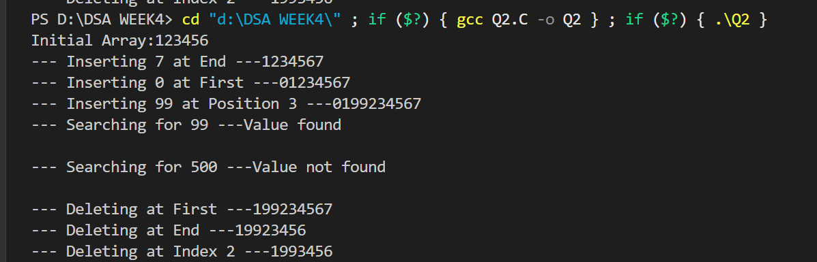

4.Find Second Largest and Second Smallest in an Array
Write a program to find:
• largest
• second largest
• smallest
• second smallest
in a single traversal if possible. Then explain:
• what happens when all elements are same?
• what happens when duplicates exist?
Example: [8, 2, 5, 2, 9, 9, 1]

2. Algorithm / Logic
Initialize four variables:
largest
secondLargest
smallest
secondSmallest
Set initial values:
largest = INT_MIN
secondLargest = INT_MIN
smallest = INT_MAX
secondSmallest = INT_MAX
Traverse the array only once.
For each element:
If element > largest
Update secondLargest = largest
Update largest = element
Else if element > secondLargest and element != larges
Update secondLargest
Similarly update smallest and secondSmallest.
After traversal print all four values.
Code:
#include <stdio.h>
int array[10] = {1, 2, 3, 40, 50, 67};
void FindLargestAndSecondLargest()
{

int Largest = array[0];
int secondLargest;
for (int i = 1; i < 6; i++)
{
if (array[i] > Largest)
{
secondLargest = Largest;
Largest = array[i];
}
else if (array[i] > secondLargest && array[i] !== Largest)
{
secondLargest = array[i];
}
}
printf("The largest element is %d and the second largest element is %d", Largest, secondLargest);
}
void FindSmallestAndSecondSmallest()
{
int smallest = array[0];
int secondSmallest;
for (int i = 1; i < 6; i++)
{
if (array[i] < smallest)
{
secondSmallest = smallest;
smallest = array[i];
}
else if (array[i] < secondSmallest && array[i] != smallest)
{
secondSmallest = array[i];
}
}
printf("\nThe smallest element is %d and the second smallest element is %d", smallest, secondSmallest);
}
int main()
{
FindLargestAndSecondLargest();
FindSmallestAndSecondSmallest();
return 0;
}

4. Dry Run with Sample Input
Initial Array:
[8, 2, 5, 2, 9, 9, 1]
Element | Largest | Second Largest | Smallest | Second Smallest
8 | 8 | -∞ | 8 | ∞
2 | 8 | 2 | 2 | 8
5 | 8 | 5 | 2 | 5
2 | 8 | 5 | 2 | 5
9 | 9 | 8 | 2 | 5
9 | 9 | 8 | 2 | 5
1 | 9 | 8 | 1 | 2
Final Result
Largest = 9
Second Largest = 8
Smallest = 1
Second Smallest = 2

5. Time Complexity
O(n)
Because the array is traversed only once.

6. Space Complexity
O(1)
Only a constant number of variables are used.

7. Special Case Explanations

Case 1: When All Elements Are Same
Example:
[5,5,5,5]
Result:
Largest = 5
Second Largest = Not available
Smallest = 5
Second Smallest = Not available
Because there is no distinct second value.

Case 2: When Duplicates Exist
Example:
[8, 2, 5, 2, 9, 9, 1]
Duplicates are ignored for second largest and second smallest because we check:
arr[i] != largest
arr[i] != smallest
So the correct result becomes:
Largest = 9
Second Largest = 8
Smallest = 1
Second Smallest = 2

Final Output Screenshot
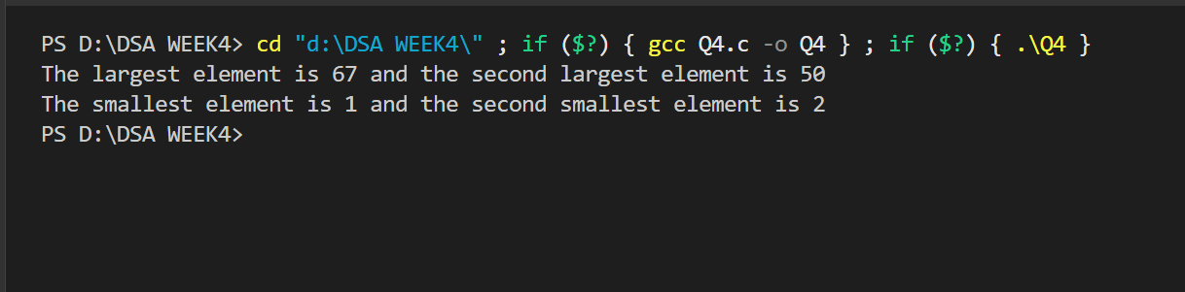

窗体顶端

窗体底端
Q3. Dry Run of Array Insertion
Given the array:
[10, 20, 30, 40, 50]
Capacity = 10, Current size = 5
Show step by step how the array changes when:
1. Insert 5 at index 0
2. Insert 25 at index 2
3. Insert 60 at the end
Also state the time complexity of each insertion.

2. Algorithm / Logic

Insertion at Beginning
Check if array is full.
Shift all elements one position to the right.
Insert new element at index 0
Increase array size.

Insertion at Specific Position
Validate position
Shift elements from that position to the right.
Insert new value.
Increase array size.

Insertion at End
Check for overflow.
Insert element at size index.
Increase size.
3. Source Code (C)
#include<stdio.h>
int array[100]={1,2,3,4,5,6};

void instert(int n,int pos)
{
int i;
for(i=7;i>pos;i--)
{
array[i]=array[i-1];
}
array[pos]=n;
printf("Element inserted successfully\n");
}
int main()
{
//1. Insert 5 at index 0
instert(5,0);//its Time complexity is O(n) because we have to shift all the elements to the right to make space for the new element at index 0.
//2. Insert 25 at index 2
instert(25,2);//its Time complexity is O(n) because we have to shift all the elements from index 2 to the right to make space for the new element at index 2.
//3. Insert 100 at End of the array
instert(100,6);//its Time complexity is O(1) because we can directly insert the new element at the end of the array without shifting any elements.
return 0;
}

4. Dry Run with Sample Input

Initial Array
Index: 0 1 2 3 4
Array: [10, 20, 30, 40, 50]
Size = 5
Capacity = 10

Step 1: Insert 5 at Index 0
Shift elements right:
[10,20,30,40,50] → shift → [_ ,10,20,30,40,50]
Insert 5:
[5,10,20,30,40,50]
New Size:
Size = 6

Step 2: Insert 25 at Index 2
Current Array:
[5,10,20,30,40,50]
Shift elements right starting from index 2:
[5,10,20,30,40,50]
↓ shift
[5,10,_,20,30,40,50]
Insert 25:
[5,10,25,20,30,40,50]
New Size:
Size = 7

Step 3: Insert 60 at End
Insert element at index size
[5,10,25,20,30,40,50,60]
New Size:
Size = 8
- Time Complexity

Operation | Time Complexity | Reason
Insert at beginning | O(n) | All elements must shift
Insert at index 2 | O(n) | Elements after index shift
Insert at end | O(1) | Direct insertion

6. Space Complexity
O(n)
Because the array stores n elements.
No additional memory is used.

7. Final Output Screenshot
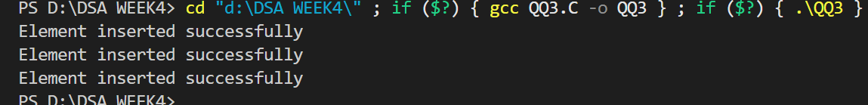

Q5. Reverse an Array In-Place
Write a function to reverse an array without using extra array space. Then answer:
• What is the time complexity?
• Why is this called an in-place algorithm?
• Can this be done recursively?

2. Algorithm
Initialize two pointers
start = 0
end = n - 1
Repeat while start < end:
Swap the elements at start and end.
Increment start.
Decrement end.
Continue until both pointers meet in the middle.The array becomes reversed.
Code
#include <stdio.h>

void ReverseArray(int arr[], int size)
{
int start = 0;
int end = size - 1;
int temp;

while(start < end)
{
temp = arr[start];
arr[start] = arr[end];
arr[end] = temp;

start++;
end--;
}
}

int main()
{
int arr[] = {1,2,3,4,5};
int size = 5;

printf("Original Array:\n");

for(int i=0;i<size;i++)
{
printf("%d ",arr[i]);
}

ReverseArray(arr,size);

printf("\n\nReversed Array:\n");

for(int i=0;i<size;i++)
{
printf("%d ",arr[i]);
}

return 0;
}

4. Dry Run with Sample Input
Initial Array:
[1,2,3,4,5]

Step 1
Swap index 0 and 4
[5,2,3,4,1]

Step 2
Swap index 1 and 3
[5,4,3,2,1]

Step 3
Now start = end, loop stops.
Final Reversed Array:
[5,4,3,2,1]

5. Time Complexity
O(n)
Because the algorithm traverses half of the array once.

6. Space Complexity
O(1)
Only one temporary variable is used.
No extra memory is required.

7. Why is this called an In-Place Algorithm?
This algorithm modifies the original array directly without using additional data structures.
All operations occur within the same memory space, which is why it is called in-place.

8. Can this be done recursively?
Yes, the array can also be reversed using recursion.
The recursive function swaps the first and last elements and then calls itself for the remaining subarray.
Output
